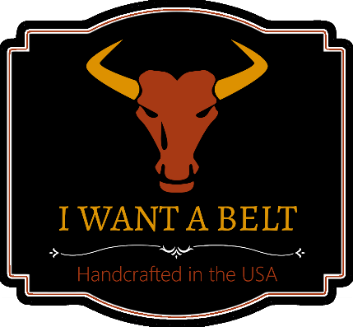

Celebrating 1 Year in Business, Continuing a Much Longer Legacy

PRESS RELEASE FOR IMMEDIATE RELEASE: February 2022

One year ago, small businesses across America were struggling. But despite the economic conditions, Nathan DiPietro started his leather belt business (I WANT A BELT). In entering the world of leather, he was carrying on a legacy that had begun decades earlier when his great-grandfather immigrated to America in search of a better life. The company is celebrating one year as the legacy continues.

JACKSONVILLE, FLORIDA: It was one year ago when Nathan DiPietro officially launched his custom leather belt business: I WANT A BELT. 2021 was a difficult year for small businesses, but his business now celebrates its one-year anniversary, and Nathan is thankful that the DiPietro legacy can continue another year.

Like many American stories, his business is rooted in a heritage that spans nearly a century. His great-grandfather, Anthony DiPietro immigrated to the US from Italy in the early 1900s. Later, both Anthony and his son, Jim, would each work in the leather and shoe repair trade.

Nathan’s grandfather (Jim, aka “Papa”) operated his own shop for over 50 years in Northeast Florida. Several years ago, Papa suffered from a cardiac arrest that nearly took his life. Miraculously, he survived. After spending almost a month in the hospital, he was finally able to leave. It was during this time that Nathan had the privilege of working alongside Papa as he recovered.

Nathan recalls, “While helping Papa, I gained an appreciation for quality leather and craftsmanship.” Over a year later, Papa passed away. At the time, Nathan didn’t feel prepared to take over the operation, and sadly, the business closed.

Years after, Nathan desired to see the DiPietro legacy continue. So, in time, he came to see a void in the leather belt market. Papa’s slogan was “quality over quantity”. Yet, as he looked at most belts available, he realized that quality was rare. He found that most stores only offer low quality belts that will quickly disintegrate with use.

Nathan was determined to shake that norm. He believed that people still cared about quality and would choose it if given the option. So, he launched iwantabelt.com. Over the past year, customers from across America have been able to use the site’s interactive “Belt Builder” to design their own custom belt. His belts are crafted with durable hardware and Italian leather. Unlike what big-box stores can offer, each belt is hand customized for each order.

Since starting the company a year ago, there have been many challenges. But, a year has passed and the legacy presses on. What lies ahead for I WANT A BELT? Nathan shared, “My vision is more than belts. I want to bring quality back into style.” In the next few months, Nathan has plans to roll out some unique buckle options, customizable dog collars, and more. Obviously, no one knows how 2022 will unfold, but Nathan is optimistic as he carries on a legacy of quality.

**END**

**###**